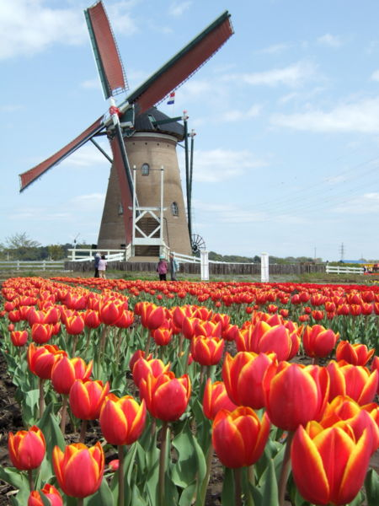 The windmill-home of the Netherlands, originating from the high amount of workers who operated windmills as their occupation, serves as another example Dutch ingenuity. In the early 1850s, about 10,000 windmills were in operation in the Netherlands. Because they were so in-demand, many who built them converted them into a residence, either by expanding them in the central column to include living space, adding space the base of the construction, or building a house into the side of the mill. These are usually identifiable by a larger size and an abundance of windows. Though the windmill-house is dwarfed by the amount of townhomes, apartments, and classical cottages throughout the Netherlands, especially Holland, many are still in existence, and serve as a testament to the hardworking nature of the nation’s hardworking people at the time. In modern times, many of these mills have been repurposed for more useful operations, such as pumping current water systems in times of needs. The current iteration of windmills, wind turbines, used to generate electricity, can now be found easily all over the Netherlands’s terrain, serving as a tribute to its humble predecessor.